PLAN BOOK DRAFT - COPY

Intro of Agency & Team Members

Overview (Executive Summary)

FOX Sports, one of the country’s most popular sports broadcasting stations, has recently announced a four-year agreement with Premier Boxing Champions (PBC) and is seeking to expand their viewership. As boxing’s landscape has drifted toward a more niche market in recent decades, many Americans are unaware that most PBC fights are now available on cable through FOX Sports. Our goal is to increase awareness for PBC and spark interest in boxing as a whole by shining a spotlight on Fox Sports as the premier home for boxing’s biggest names and best fights. We developed a creative marketing campaign to promote Fox’s goal of bringing top-tier championship fights back to the masses.

Ask

In September 2018, FOX Sports announced a landmark four-year, multi-platform agreement with Premier Boxing Champions (PBC), making FOX Sports the preeminent broadcaster for PBC’s top-tier championship fights. Currently, we are developing a creative marketing campaign that FOX Sports and the PBC can utilize together in order to increase fan awareness, engagement, and viewership of the PBC on FOX and FS1. We are working to determine how FOX Sports can help build excitement around PBC live events.

Deliverables
- Research on the PBC fan and audience
- All-encompassing PBC on FOX marketing strategy that includes:
  - Creative taglines
  - Digital + social media content
  - Off-air promotion
    - PR + Talent activations, stunts, OOH messaging, etc.
    - Consumer activations (on-site, off-site and consumer facing)
  - On-air promotion
    - Commercial spots for FOX, FS1 and FOX Deportes
    - Cross channel integration (i.e. what other FOX properties could you leverage whether it be studio shows or live events to push out the PBC message

Research

Secondary
- Short Secondary Research Description (think goals of what we wanted to accomplish): Our goal with secondary research was finding the strengths, weaknesses, opportunities and threats of boxing as well as learn more about the current perception of boxing and its position in the sports landscape. Creating a SWOT for PBC on Fox allowed us to learn about ways that PBC can be promoted as well as the challenges facing PBC and the sport of boxing. Our secondary research gave us an initial glance into boxing’s place on the sports entertainment landscape.

Primary
- Short Primary Research Description (think goals of what we wanted to accomplish through our idi’s): Our primary research mostly confirmed our discoveries with secondary research. Our in-depth interviews revealed that the pay-per-view barrier was creating a lack of accessibility for the sport of boxing. Also, fans need a way to connect with the boxers they support and are interested in their background stories and life outside of the rink. Finally, the fighters themselves were not the only aspect of the sport fans were drawn to. Boxing has always been associated with a flair for the dramatic, and the hype can be seen in weigh-ins, trash talk leading up to the fights, and the spectacle of attending a match live.

SWOT

Strengths:
Strengths
● Cross-promotion with other Fox programming
● Use technology to provide enhanced audio and video, making viewers feel closer to
the action
● Low cost barrier for viewers who already pay for cable
● Entertaining and knowledgeable commentators that make the match exciting

A huge strength we found that we think would benefit FOX Sports is for them to cross promote the PBC with other programming they currently have. This is an easy and relatively inexpensive way to spread awareness of the PBC on FOX to other current sports fanatics that currently watch other leagues. They also have a really low-cost barrier this way to access viewers that already pay for cable and engage with their programs regularly. FOX Sports also has the advanced technology to provide enhanced audio and video, making viewers feel closer to the action from the comfort of their homes, or out enjoying time with friends. They also have entertaining and knowledgeable commentators that make PBC matches exciting to watch.

Weakness:
● Shift away from traditional cable packages
● Viewers tend to multitask while watching
● Massive rise in popularity with UFC
● The Fox Sports website is hard to navigate and PBC could get lost in the mix

Some weaknesses we found that Fox Sports has to work forward from are that many people are tending to shift away from purchasing traditional cable packages with the rise of streaming services. Viewers also tend to multitask while watching sports which can advert their attention elsewhere instead of becoming more connected to the game or fight on TV. We also found that the UFC has gained massive popularity recently, which FOX Sports and the PBC will have to compete with in regards to gaining awareness and a bigger fanbase to combat sports. The last area of improvement we found was that the FOX Sports website is difficult to navigate and the PBC could get lost in the mix of other major sporting leagues.

Opportunities
● Marketability of the top talent in the PBC
● Fox can show consumers that today all you need to watch the top boxing is a TV with cable
● Fighter stories show viewers the process of competing at a high level and can connect to
viewers emotionally
● Shoulder programming is an additional outlet to advertise and increase awareness

Threats
With superstars with large personalities, like Conor McGregor, it can be hard to compete with other outlets such as the UFC for viewership and general interest in the sport. Also, cable TV is dying amongst a younger audience and streaming services are thriving. Some of FOX’s competitors for boxing-focused streaming services include DAZN, which offers new content to its customers. Boxing also just isn’t as prominent of a sport in the United States right now, compared to seasonal sports such as the NFL, MLB, or NBA which are always offered on cable channels and easy to view. Our last threat is that illegal pirating of matches has skyrocketed recently, making it more difficult to maintain ownership of who is viewing big name fights.

Findings :
[Loyalists]
- Boxing loyalists still would choose other big name sports events over boxing
  - “[I’d only watch boxing] if it were a huuuuge match. And the other sport wasn’t a playoff game, otherwise, an important game in an established sport always beats boxing.” - Cameron
  - “So I’m not a big fan of the promotion of boxing, I don’t think they do a good job,​ I think they should align themselves more with how the UFC does it, which is more the fighters instead of the promoters. ​The UFC where you have pretty much the fighters almost promote themselves, right? ​I think the UFC has a much higher standard for their stuff, and I think the boxing has really fallen off with kind of their standard of marketing and promoting their fights.” -Boomer
- People enjoy watching boxing because it’s personal and differs from popular team sports (part 1)
  - “Fighting is a fun sport to watch. It’s just one-on-one. The physical tension is something that I enjoy… the constant action for 30 min is exciting.” - Jerod
  - “I would watch boxing over some other sports because I know that a boxing match is going to have continuous action. If it were on at the same time as a regular season NBA game, I might watch just because I want to be interested in getting more invested in the sport.” -Logan Brunk
- People like watching sports in a social setting
  - “I tend to watch these sports in a bar setting” -Carly Pasquale (Loyalist)
- Social Aspect
  - ​“For me to watch it would have to of been with friends. I don’t think it was ever really on at my home. It was probably a [Floyd] Mayweather fight.” -Jerod Thomas
[Prospects]
- People do not realize boxing is on cable
  - “I would probably flip it on more often if it was included in cable, something to watch with friends if we were scrolling through the channels” -Zac Aron (potential fan)
  - “Only boxing I know of is on Showtime” -Tim Weinstock (potential fan)
- People enjoy watching boxing because it’s personal and differs from popular team sports (part 2)
  - “It is enjoyable to see the act of fighting turned into a sporting event. I love the adrenaline pumping and it’s a very human thing to do.” -Zac Aron (potential fan)
  - “Feels like a show, a spectacle which can be a bad thing” - Jimmy Fraus
  - “I don’t know the rules to boxing but it seems interesting” -Kasia Kerridge

- Social Aspect (part 2)
  - “Twitter is really big. I really enjoy going there for my information. I know I can go on twitter and catch up on anything I miss. I’m not really watching Sports Center at night anymore. I’m using my phone and tablet too to catch up by using social media. Most of the platforms I go to are team or sport specific. I like the more in-depth coverage.” - Alex Sommerfeldt
  - “I talk to myself when watching sports or analyzing the game. When it comes to watching with family and friends, we talk a lot about the players rather than the teams. We talk a lot about the game.” -Alex Escobedo (prospect I think?)
  - “​I like following athlete’s social media and keeping up with everything that they do. I usually don’t watch press conferences but I do like seeing pre and post-fight material if the boxers can make it interesting.” -Alex Escobedo

Target

As PBC is arriving on cable television, we are targeting social spectacle seekers who are approximately 24-34 years old with a college education and an associate level job. They enjoy watching sports with their friends and see boxing as a form of entertainment to be shared with others as opposed to viewing alone. After working hard all week, they want to spend the weekends out relaxing at bars and restaurants or relaxing on the couch at home, but either way surrounded by food, drink and company. They do not hesitate to place friendly wagers with friends and family to invest in the potential outcome of the sports they watch.

Consumer Insight Quote

“I’ve watched sports on cable my entire life, and the most popular network have always shown the most popular sports like football, basketball, baseball and hockey. It’s not that I don’t like boxing… I guess I just don’t know enough about it to have an opinion in the first place. My dad keeps telling me about that one time Mike Tyson bit a fighter’s ear off, but watching a sporting event live gives me much more of an adrenaline rush compared to watching some old YouTube highlights. Some friends invited me over to their apartment for a watch party during the Mayweather - Pacquiao fight a few years ago and I could tell the boxers use a lot more strategy than UFC fighters, who just seem to maul each other. It was cool to witness the FIght of the Century because I knew it was a heavily anticipated event and lounging around with some wings, beer and friends certainly made it more fun to watch.” - Social Spectacle Seeker

Insights (lead up to strategy)

- Boxing’s relative lack of familiarity is related to its lack of accessibility
- Sports are a social experience enjoyed with others
- The level of competition involved drives interest

Strategy

Attract Social Spectacle Seekers who aspire to learn more about the PBC by positioning Fox Sports as the premier home of boxing’s biggest names and best fights.

Big Idea

As the premier destination for boxing, FOX is home to some of the biggest and best fights.
- *Boxing has found its home on Fox*
- Tagline = Home is where the fight is

Tactics (CREATIVE)

- Video

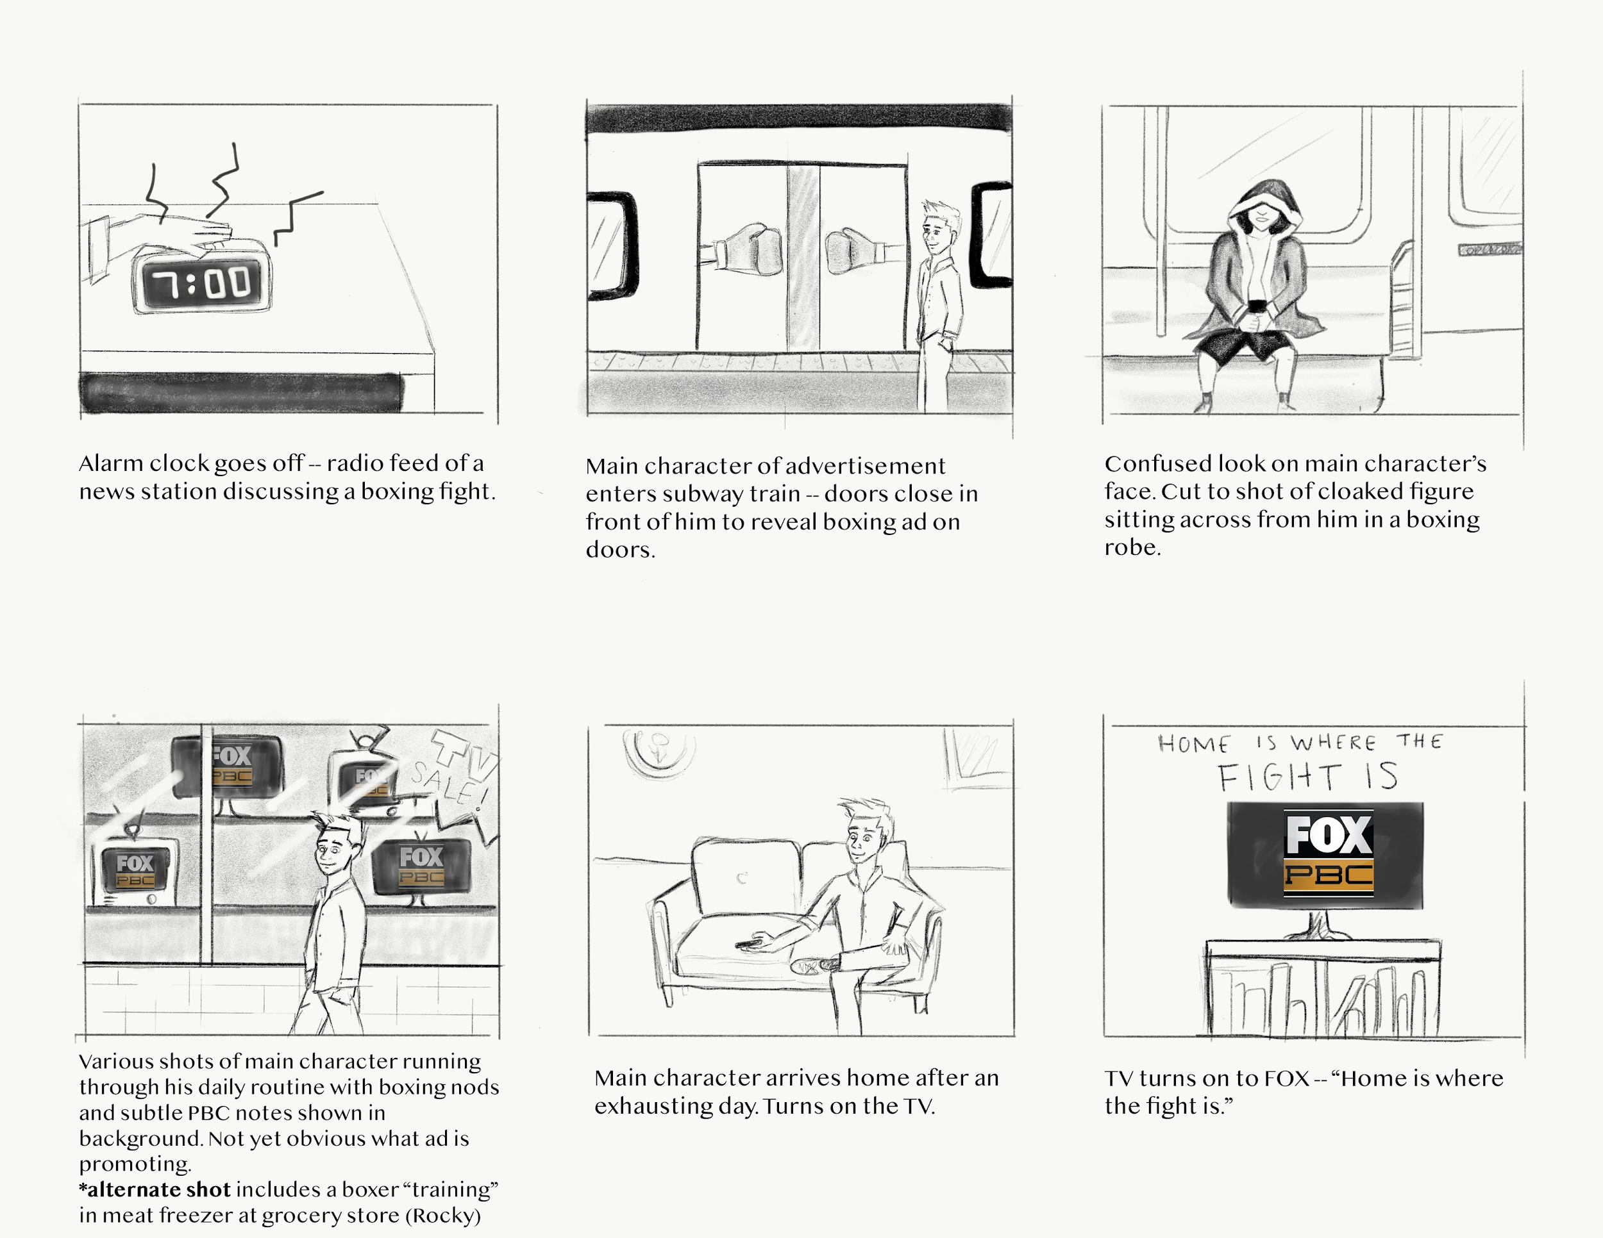

- PR
  - Punching bag idea:
    - Arcade boxing game with the tagline “boxing has come to your hometown”
    - Placement in areas where people are generally frustrated

Interactive Punching Bag:

To spark consumer engagement, we want to place a boxing arcade game in areas with high foot traffic around major US cities. These arcade games would be accompanied with iPads to track how powerful each punch is and display a leaderboard with the hardest hits around the country. The hardest puncher will be given a ringside ticket to an upcoming PBC match and they can provide a post-fight testimonial of their experience that can be used for future advertising. The tagline for these machines would be “Do you have what it takes to join the next generation of boxing?” Everything on the machines would be labeled with the PBC on Fox logo and will have a listing of upcoming PBC fights.

These machines should be placed in areas where people are generally mad, stressed, or frustrated about a situation and looking to blow off some steam. Such locations could the DMV, grocery stores and subway/bus stops. Sports bars and restaurants would also be vital locations for placing these machines, as they are areas where our target demographic loves to socialize, eat, drink, and watch live sporting events. Other sites to consider placing these machines could be places where people are typically active like parks or gyms. When a boxing match is coming to a particular city, the week leading up to the fight would be an appropriate time to place these interactive punching bags throughout the urban area. Doing this would foster competitiveness and let individuals engage with the sport of boxing, possibly for their first time.
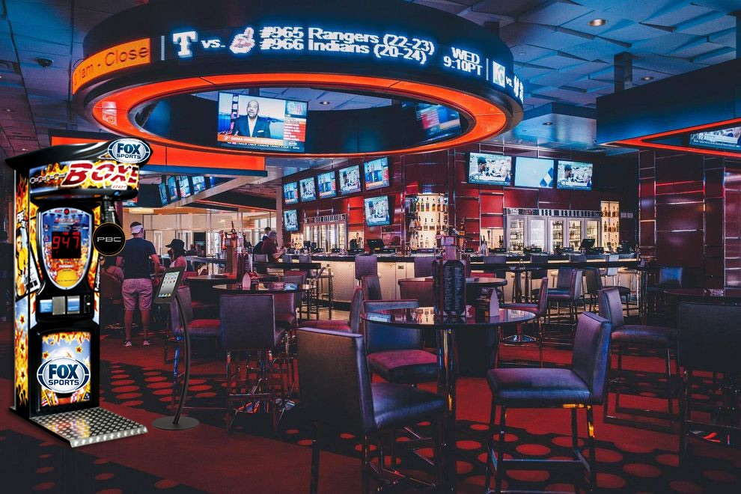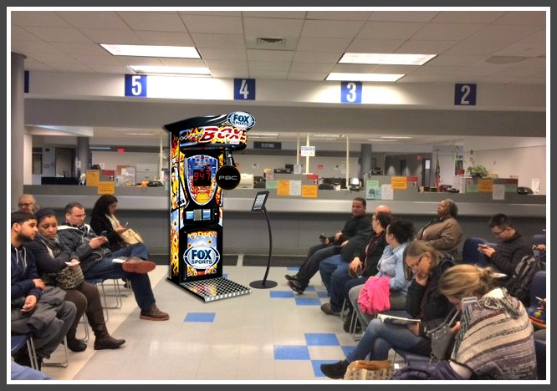
  - Boxing living room idea:
    - Boxing ring with a home setup within it
      - Furniture, TV, rug, etc.
    - Boxing gloves and helmets would be placed in the ring if people would choose to use
    - Could use the pictures of the ring in billboards, online ads, etc.
    - https://mailmissouri-my.sharepoint.com/:v:/g/personal/savbb4_mail_missouri_edu/EZwBpYkwgVROt5GNPrGX_koB9DQQhKYgHEdO2jkXGHqoPQ

Living Room Anywhere:

For this experiential campaign, our goal is the bring the comfort of a living room to the boxing ring. We want to promote the idea of Fox as the home of boxing with a PBC-on-Fox branded boxing ring with all of the furniture and luxuries of a living room set up inside the ring. These roped-off boxing rings would be placed in urban shopping malls and in potential partnering restaurants such as Buffalo WIld Wings as a type of VIP seating area when primetime fights are on.
Consumers would be able to get in the ring and relax on the couches placed inside while watching PBC fight nights on Fox. Within the boxing ring would be a flat screen TV, sofa, rug, coffee table with PBC coasters, boxing gloves, and other items to make the area seem like home. The goal of this set up is to promote the PBC in an interactive way that would grab people’s attention.
This visual concept of placing a living room inside of a boxing ring could also be implemented into out-of-home advertisements such as billboards. “Welcome to the home of boxing” would be the tagline placed on the welcome rug to associate Fox with the PBC boxing league.

- Digital / Social
  - Digital Tactic: PBC Boxers will interact with Youtube Sports Channels and Bloggers in this fun Youtube series. PBC Boxers will surprise pointed influencers and bloggers at their homes. Youtube Influencers/Channels will then have time to do an in-depth interview about the boxers. Interviews can include topics such as boxing styles, potential matches, hometown life, favorite foods, etc. This will all be up to the influencer/blogger to create a genuine relationship with the audience.These are some current Channels/Bloggers we would partner with:
    - FightHype.com
      - 462K Subscribers
      - Almost 545,000,000 views
      - Focus: Boxing & MMA
    - Dontae’s Boxing Nation
      - 220K Subscribers
      - More than 130,000,000 views
      - Focus: Raw, uncut, real boxing talk
    - Editinking
      - 535K Subscribers
      - Almost 300,000,000 views
      - Focus: “Welcome to the home of boxing”
    - Storyboard:
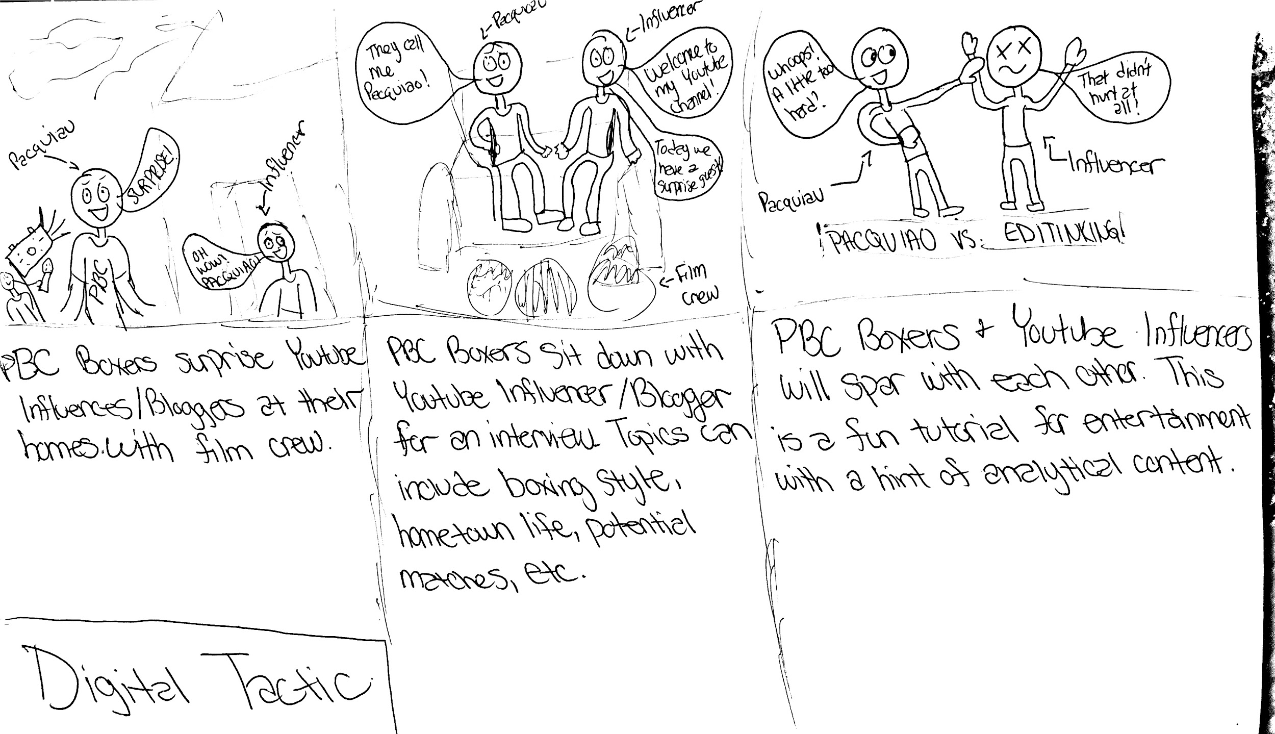
- Social Media Tactic
  - Hometown Heroes: 30 second videos of the each boxer discussing their hometowns. This can include where they grew up, family makeup, boxing influences, traditions, and any other activities related to their childhood. This not only allows viewers to get to know the fighters stories, but also ties back into our big idea of boxing finding a home on FOX.
  - 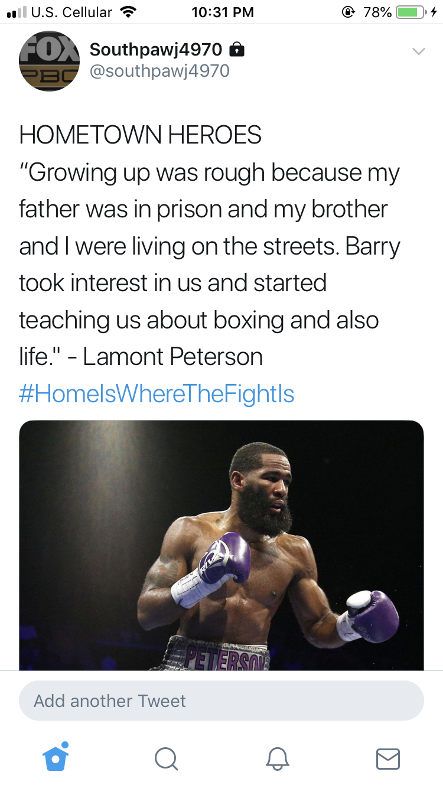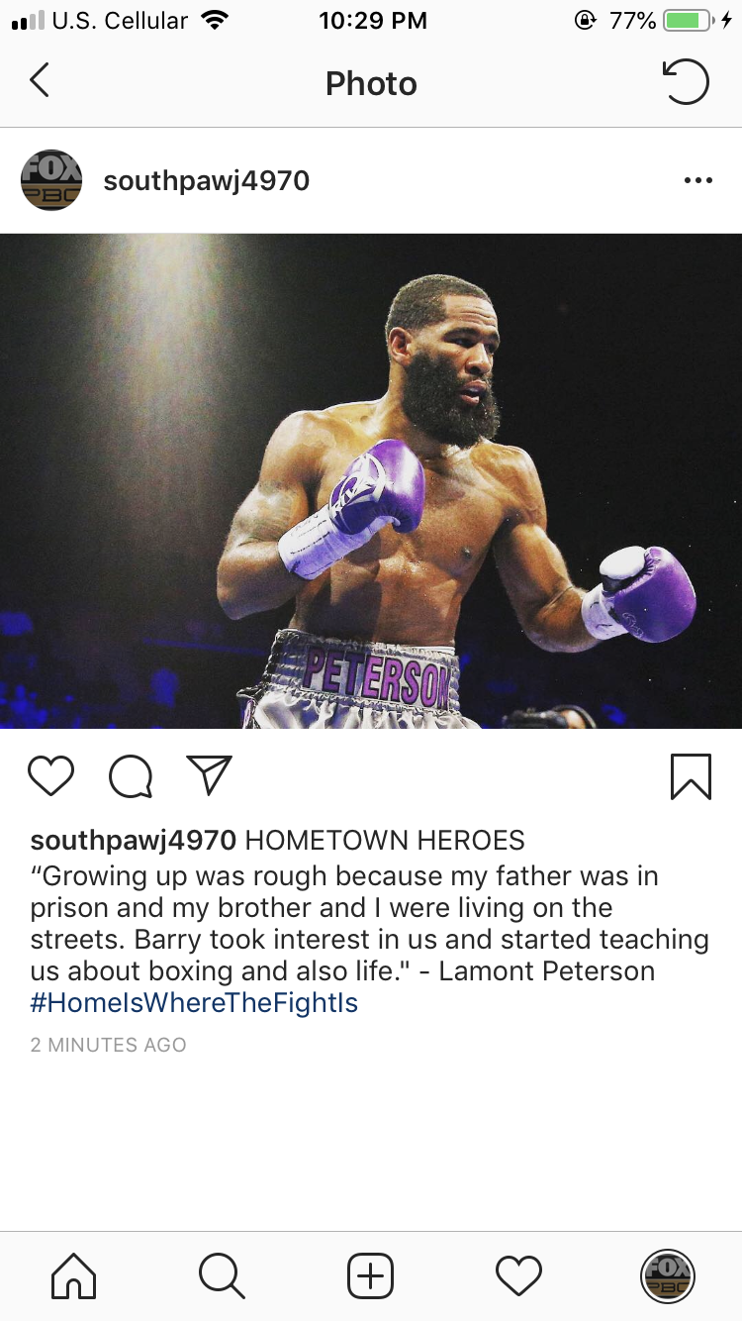

  - Get To Know You: Boxers will self-analyze their boxing styles and techniques in this social media segment. According to our research, one of the reasons people aren’t watching boxing is because they don’t know anything about the athletes]. This video analysis will provide content to bridge that gap. Each video will be 30 seconds long and posted on Facebook, Twitter, Instagram, Youtube, and Snapchat. The clips can be run strategically based around certain fights, for example Jarrett Hurd is fighting Julian Williams on May 11th. The week leading up to the Hurd Williams fight, both of their segments could be aired.
  - 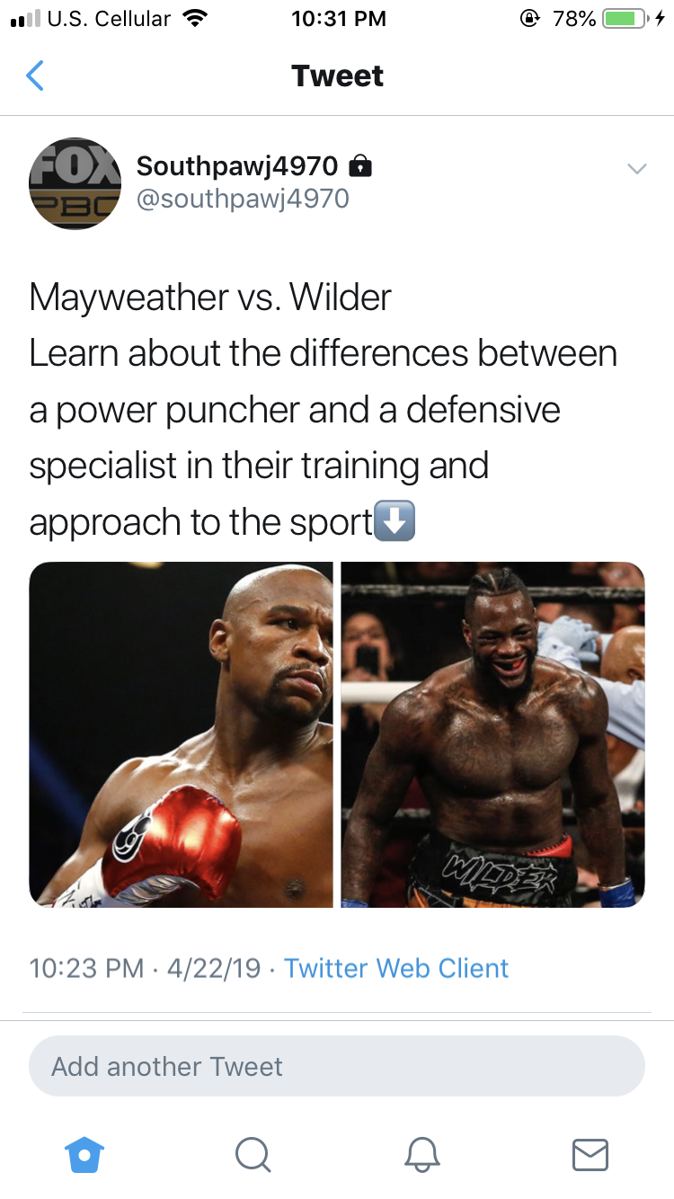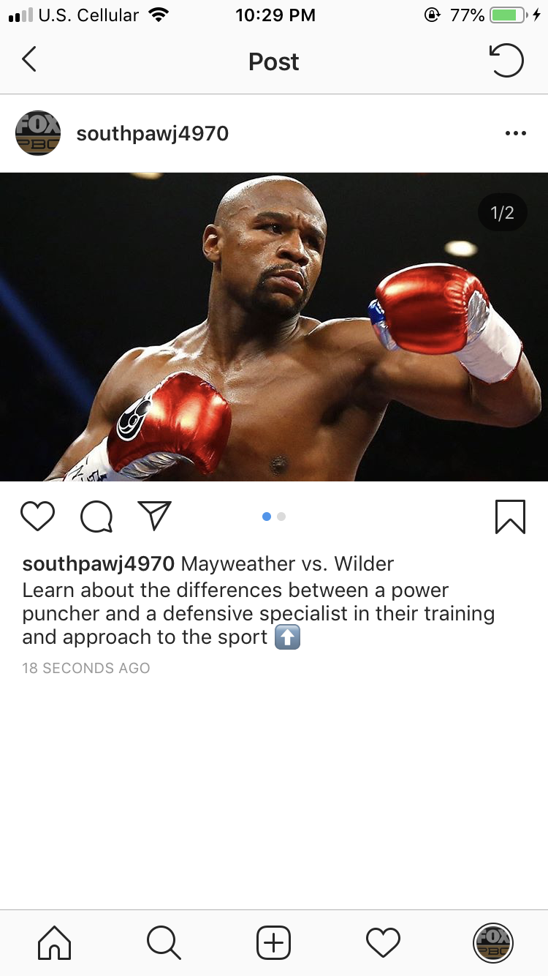
  - Storyboards:
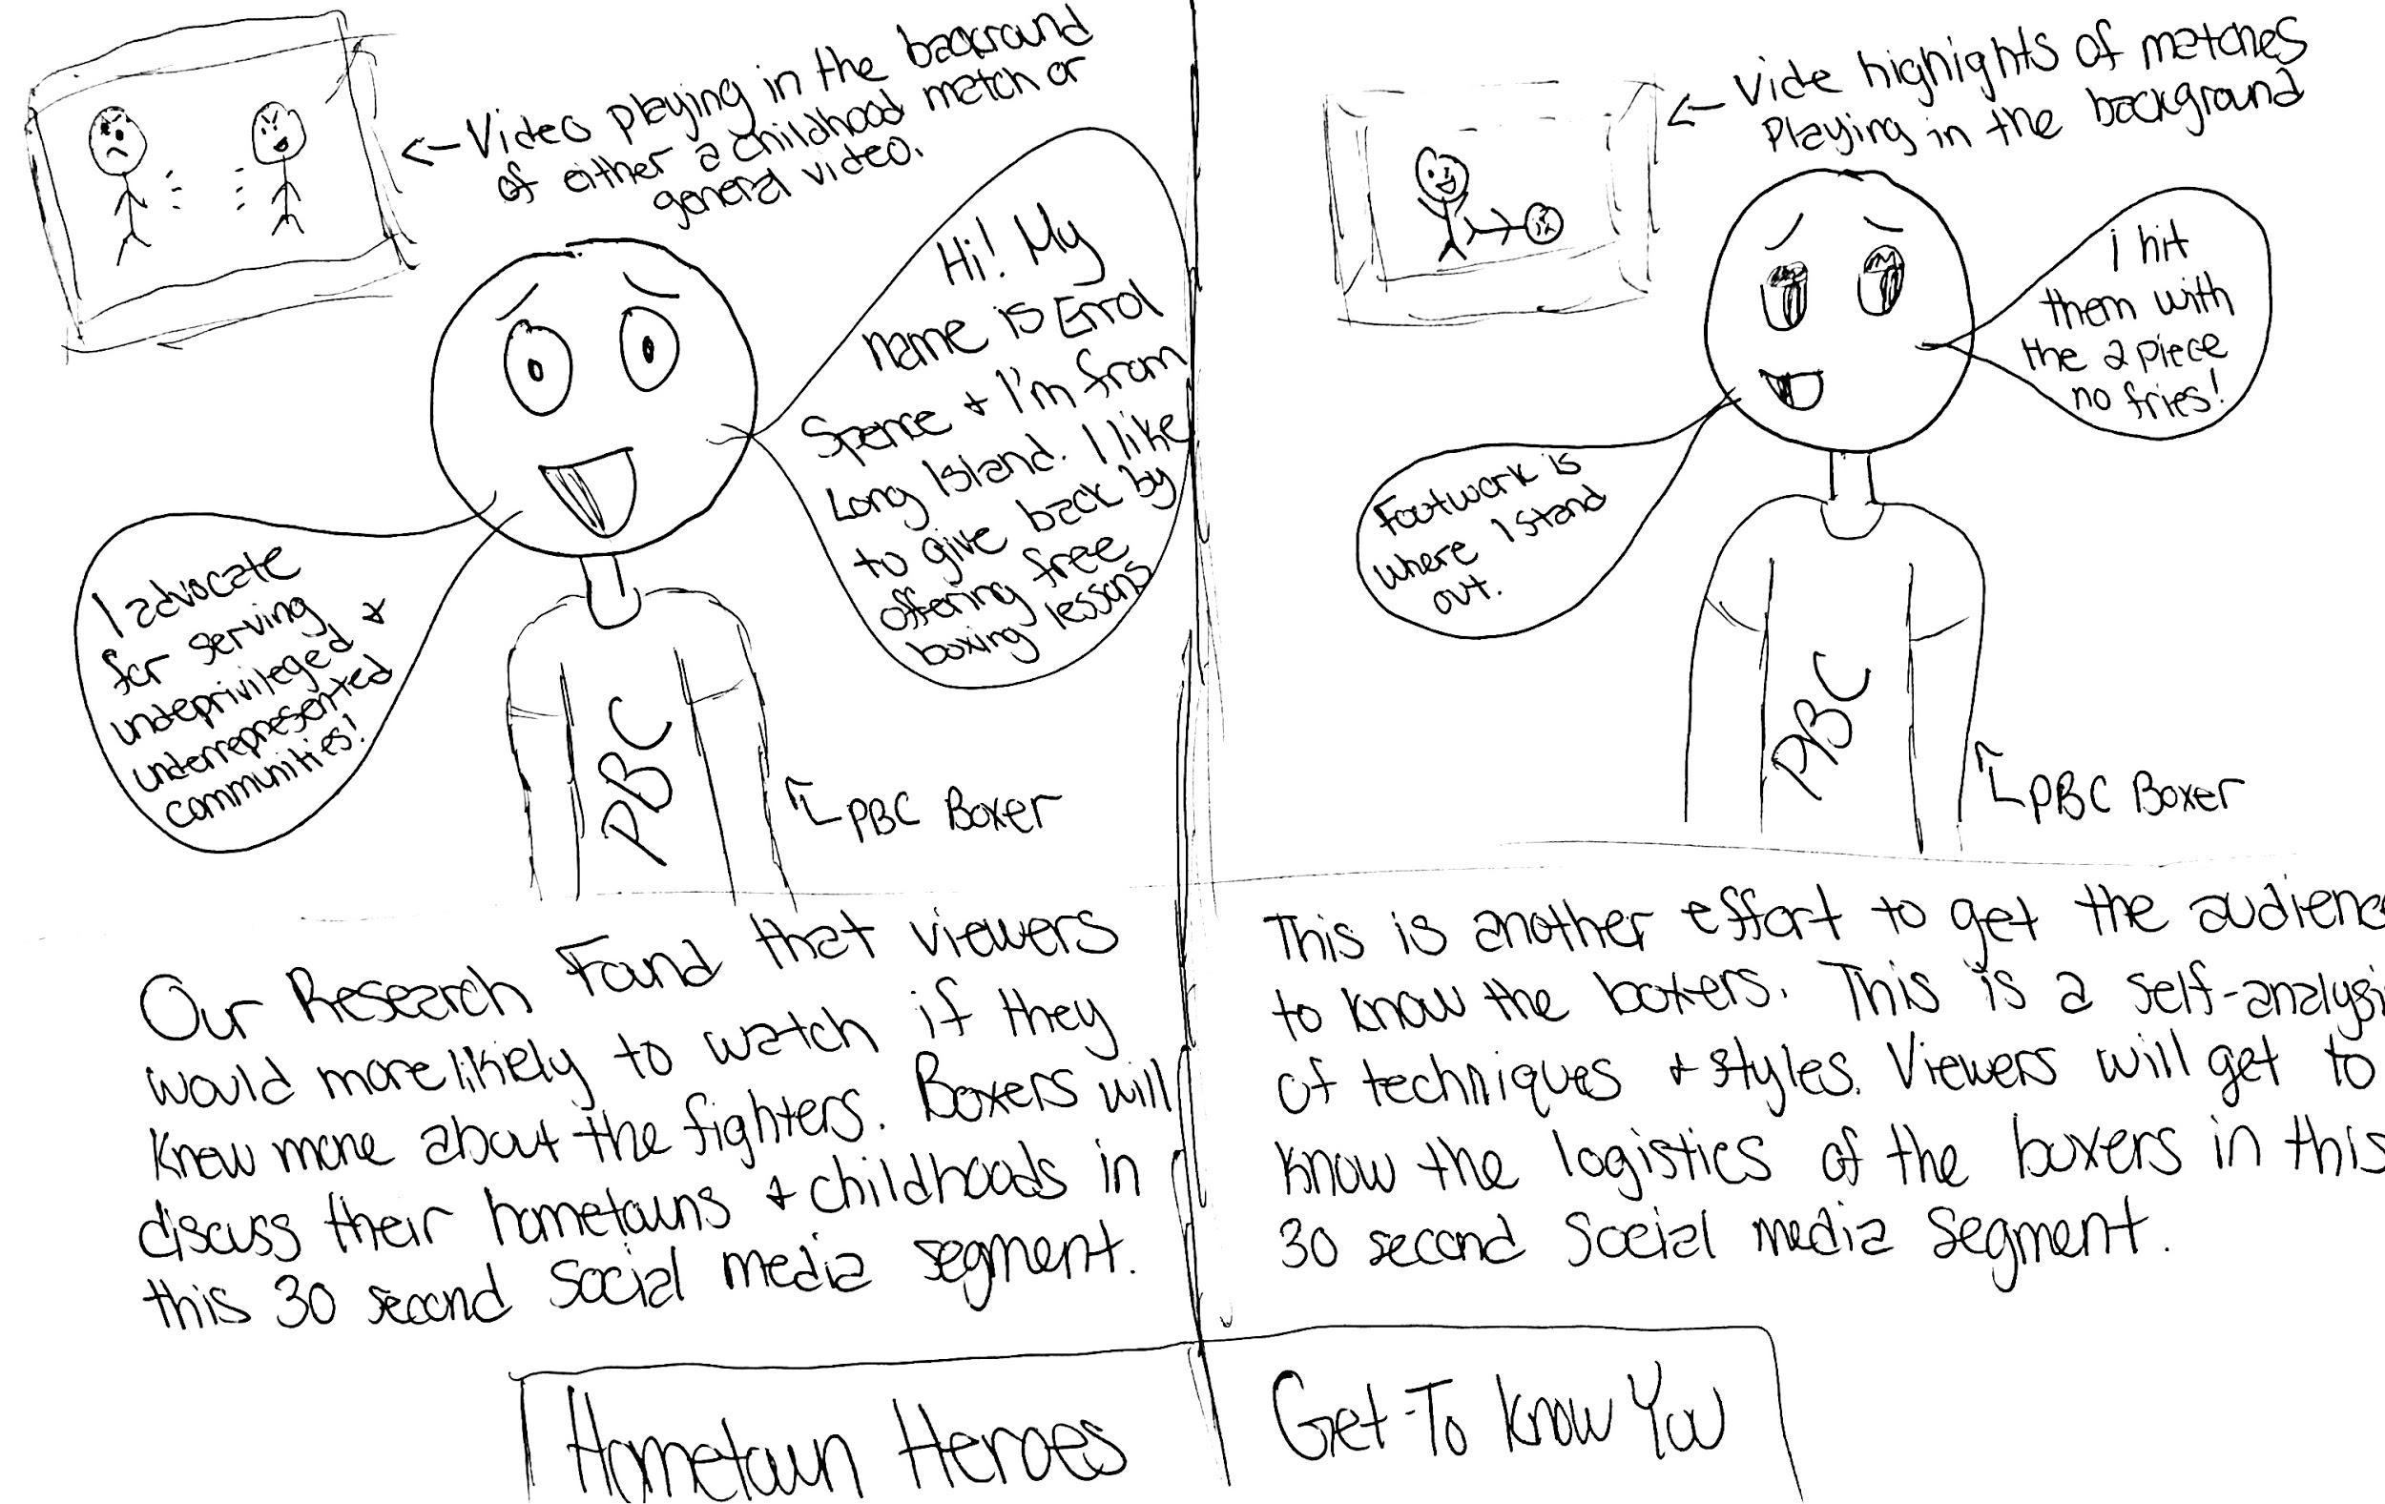

  - Polls -
    - Twitter polls, Facebook polls, Instagram Story polls, Youtube ad polls.
    - The main point of our polls is to increase audience engagement. We want them to feel as though they are active participants in the boxing journey and that they have a voice in where fights will be held, who they think will win the next big fight, and just show comradeship with other boxing fans by expressing where they typically enjoy watching the fights. It is also a perfect way to find out what our viewers want in order to properly serve their needs.
    - 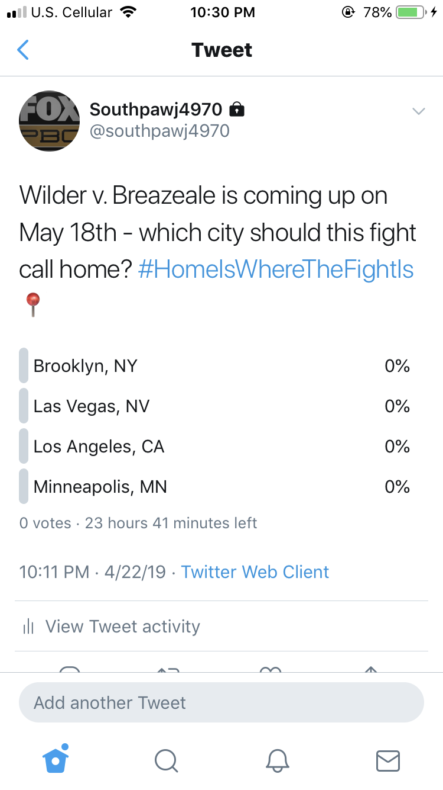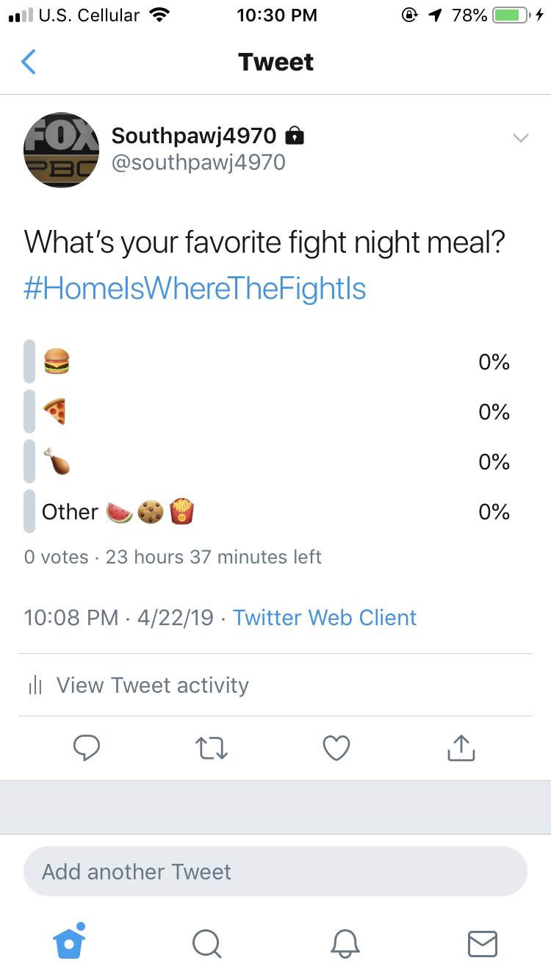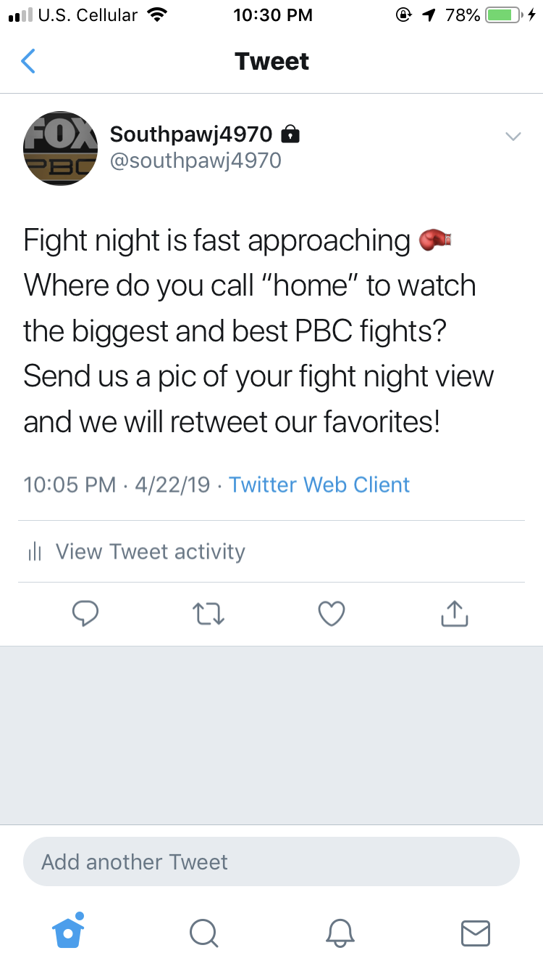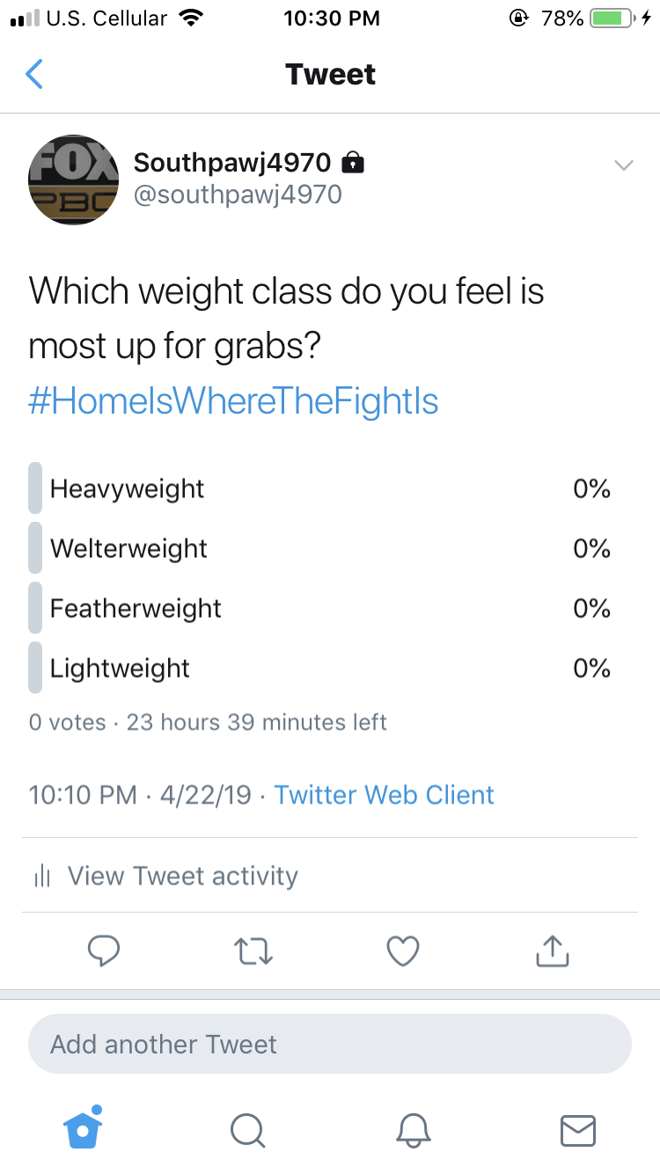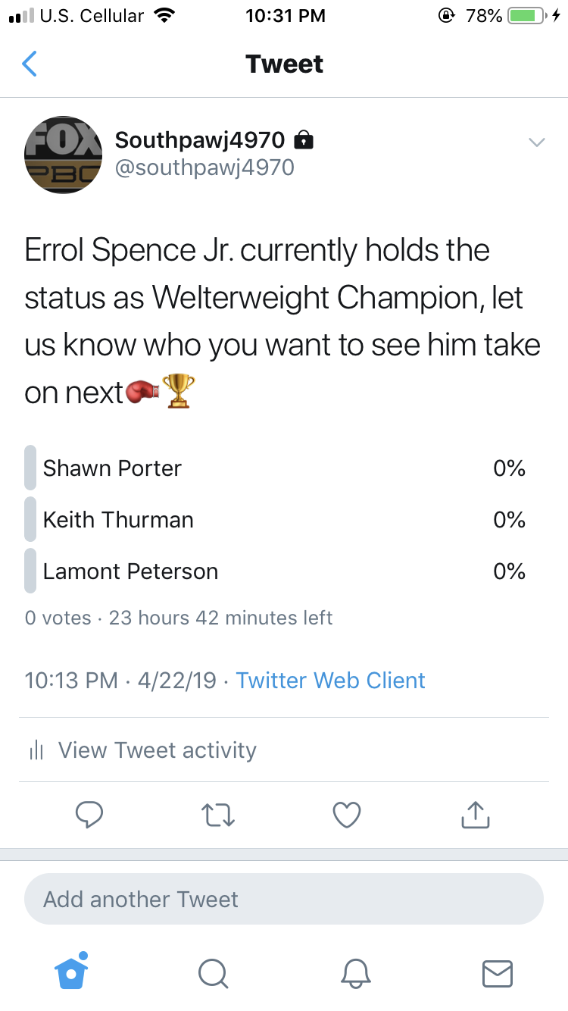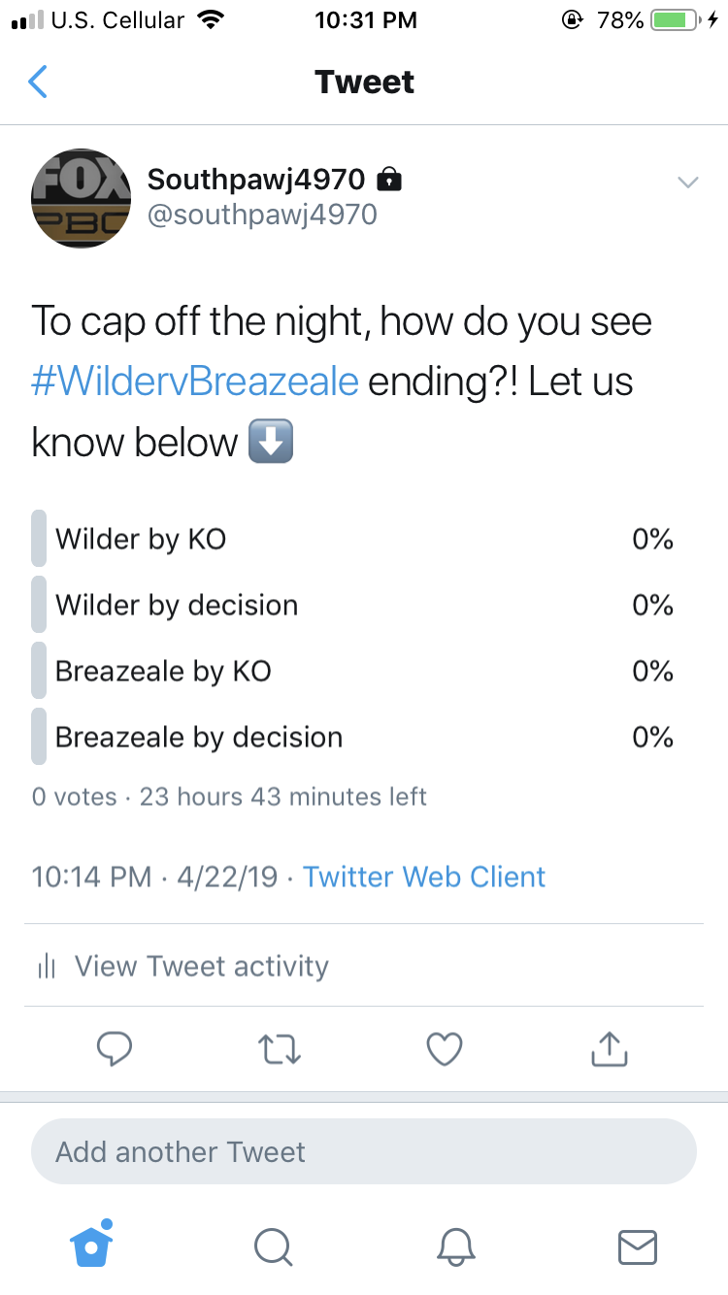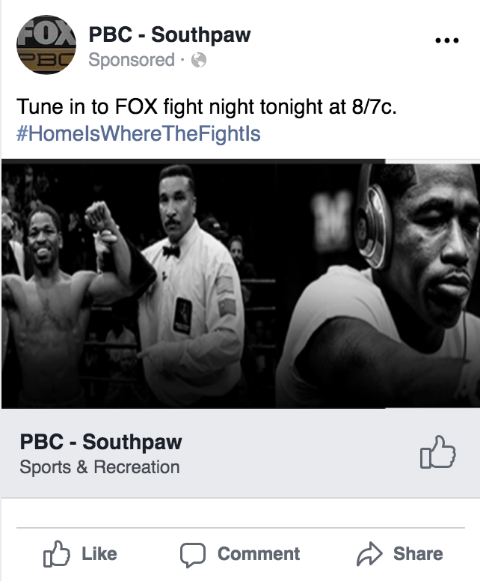

- Cross Promotion

- Discuss PBC storylines and controversy on Undisputed.
Sportswriter-turned-TV personality Skip Bayless knows a thing or two about sports debates after participating in them for more than a decade at a competing network's morning show. Now at FS1, he gets top billing on "Skip and Shannon: Undisputed," a daily show that sees Bayless offering his hot takes on the latest sports news opposite Pro Football Hall of Fame inductee Shannon Sharpe, who expands his horizons beyond just pigskin. Joy Taylor moderates and must keep things under control when the debates get heated.
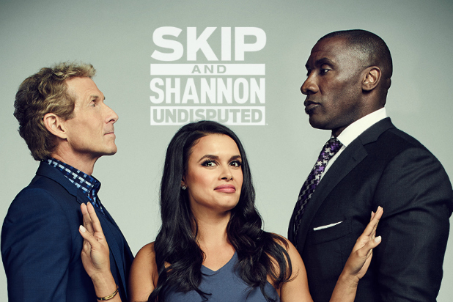

2. Discuss upcoming PBC fights featured on FOX.
The Herd with Colin Cowherd is a sports talk radio show hosted by Colin Cowherd on Fox Sports Radio and Fox Sports 1. The show features commentary on the day's sports news, perspective on other news stories, and interviews with celebrities, sports analysts and sports figures.
3. Discuss sports betting odds for PBC fights on Straight Outta Vegas
Hosted by Las Vegas personality and founder/CEO of Pregame.com RJ Bell, the one-hour program gives fans a real-time Vegas perspective on each upcoming game’s kickoff, opening tip, and first pitch. Featuring FOX Sports Radio personality Jonas Knox, as well as famed betting experts Brad Powers and Steve Fezzik, the program will inform and entertain sports fans with on-the-ground reporting – including breaking news and changing odds – right up until game time.
- College football game close to where the fight will be
- Women’s world cup coverage, USA defending champs

Lock It In (FS1 gambling show)
Last year, the U.S. Supreme Court reversed the 1992 federal law, The Professional and Amateur Sports Protection Act (PASPA), which established a federal ban (excluding Nevada) on sports gambling. This monumental reversal allowed FS1 to expand its studio programming with its first-ever sports gambling show. It aims to make the avid sports fan smarter and more informed about making bets on events, delves into the biggest sports stories of the day, and previews the games happening that night. The weekday show is hosted by Rachel Bonnetta. She is joined by "Jimmy Kimmel Live" writer and frequent guest "Cousin Sal", sports radio show host Clay Travis, and oddsmaker Todd Fuhrman.
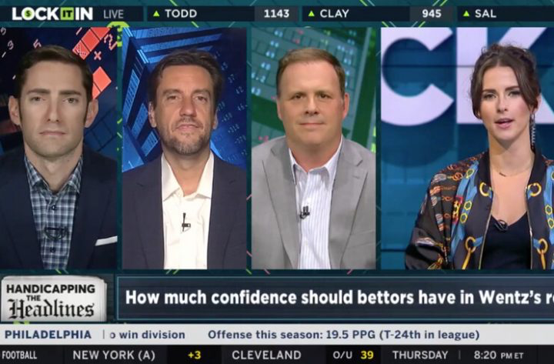

Budget / Timeline
- Draft of Timeline:
- 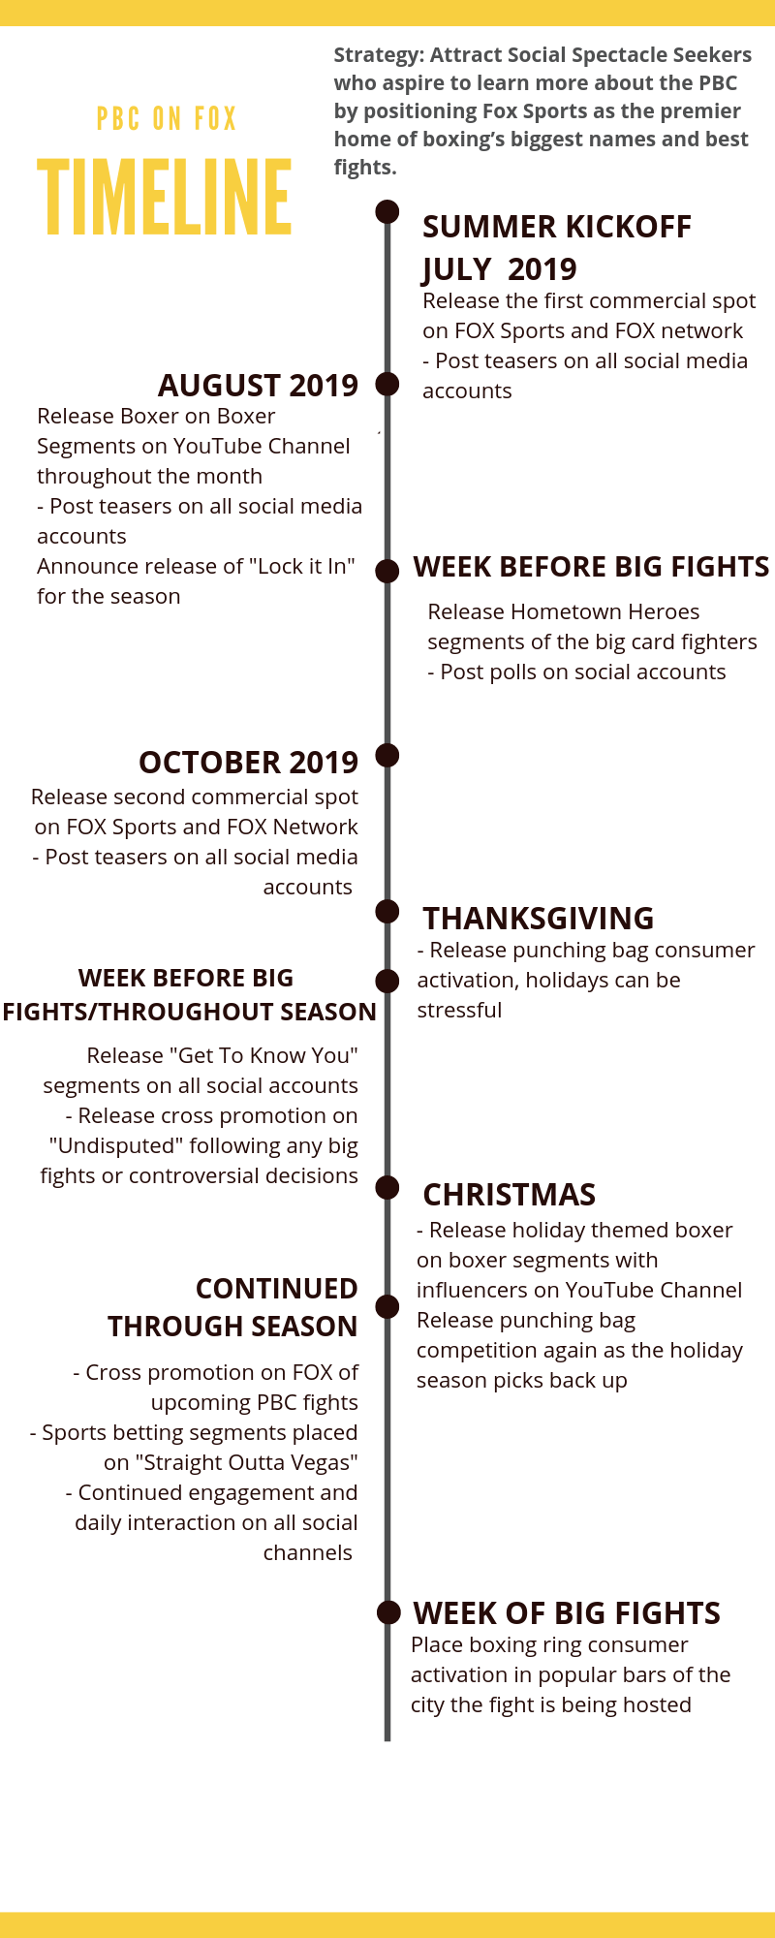

Questions

